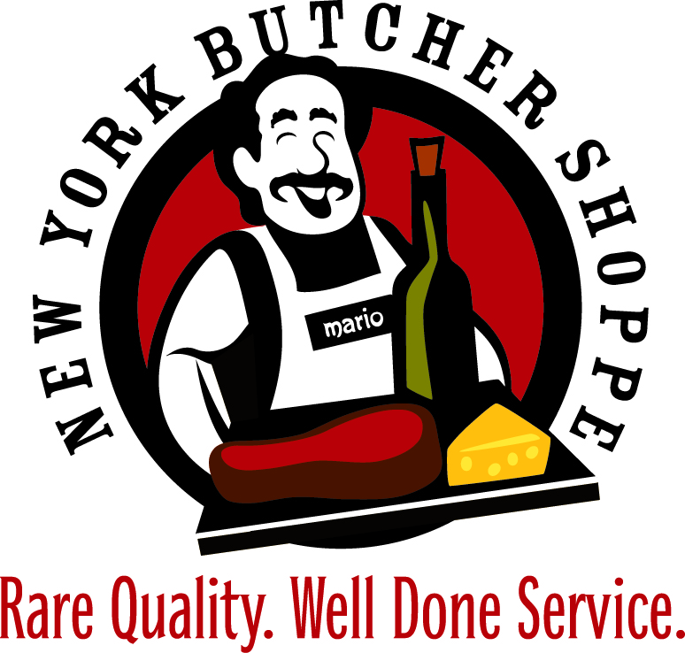
HOLIDAY ROAST MENU
All roasts are cut to your specifications by your butcher!
Certified Angus Bone-In Standing Rib Roast - $28.99/LB
Certified Angus Boneless Rib Roast - $31.99/LB
Certified Angus NY Strip Roast - $22.99/LB
Certified Angus Beef Whole Tenderloin Roast - $47.99/LB
Certified Angus Beef Prime Bone-In Standing Rib Roast - $36.99/LB
Certified Angus Prime Boneless Rib Roast - $38.99/LB
Certified Angus Prime NY Strip Roast - $35.99/LB
Certified Angus Prime Beef Whole Tenderloin Roast - $56.99/LB
Pork Crown Roast - $19.99/LB
Frenched Cheshire Pork Roast - $17.99/LB
Neuske's Apple Wood Smoked, Spiral Sliced Ham- Half- $13.99/LB
Frenched Racks of Lamb New Zealand - $27.99/LB
Frenched Racks of Lamb Domestic - $43.99 / LB
Lamb Soldier Roast New Zealand- $27.99/LB
Lamb Soldier Roast Domestic - $43.99/LB
Boneless Leg of Lamb Domestic - $16.99
Boneless Leg of Lamb New Zealand – 13.99 / LB
Boneless Leg of Lamb Australian – 13.99 / LB
Veal Soldier Roast - $39.99/LB
Veal Rib Roast - $39.99/LB
And much, much more!

Great Holiday Gift Ideas
- Meat Packages for Individuals
(or Gift Certificates for Meat Packages)
- Meat Packages as Corporate Gifts
- Wine Club Memberships
- Gift Certificates
- Wine for Hostess Gifts
- High End Wine for Bosses and Co-Workers
- Private Wine Tasting Party

