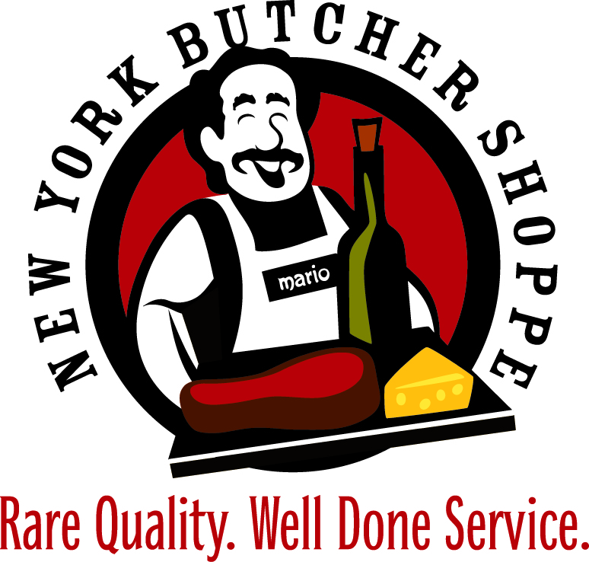
HOLIDAY ROAST MENU
All roasts are cut to your specifications by your butcher!
Certified Angus Bone-In Standing Rib Roast - $29/LB
Certified Angus Boneless Rib Roast - $33/LB
Certified Angus NY Strip Roast - $25/LB
Certified Angus Beef Whole Tenderloin Roast - $48/LB
Certified Angus Beef Prime Bone-In Standing Rib Roast - $37/LB
Certified Angus Prime Boneless Rib Roast - $39/LB
Certified Angus Prime NY Strip Roast - $38/LB
Certified Angus Prime Beef Whole Tenderloin Roast - $57/LB
Pork Crown Roast - $20/LB
Frenched Cheshire Pork Roast - $18/LB
Frenched Racks of Lamb New Zealand - $28/LB
Boneless Leg of Lamb Domestic - $17/LB
Boneless Leg of Lamb New Zealand – $14 / LB
Veal Rib Roast - $40/LB
And much, much more!

Great Holiday Gift Ideas
- Meat Packages for Individuals
(or Gift Certificates for Meat Packages)
- Meat Packages as Corporate Gifts
- Wine Club Memberships
- Gift Certificates
- Wine for Hostess Gifts
- High End Wine for Bosses and Co-Workers
- Private Wine Tasting Party

