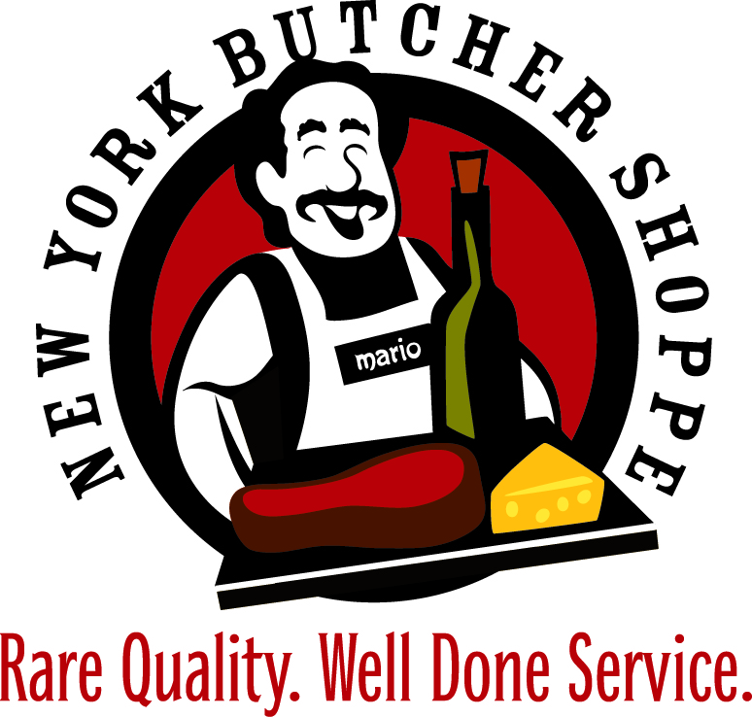
THANKSGIVING TURKEY TIME!

We are pleased to once again offer our Free-Range All-Natural Turkeys from Joyce Farms for the 2024 holiday season. Our turkeys are in high demand during the holiday season, and production is limited. Please place your orders early to ensure delivery.

Joyce Farms turkeys are specially grown on carefully selected North Carolina and Georgia turkey farms with free-range pastures allowing them to roam outside in fresh air and sunshine, the way turkeys were grown years ago. They are grown in a safe, humane, low stress environment, and fed a wholesome grain diet with no artificial ingredients, and no hormones. They are processed in a modern, USDA approved facility that follows strict sanitation guidelines and an approved HACCP program. Our turkeys are then hand selected from only the very best of the USDA Grade A birds.

Joyce Farms turkeys are different from the mass-produced factory farmed commodity turkeys found in most supermarkets today. Our turkeys are not grown to be the cheapest priced turkey in a super-market, but to be the highest quality turkey with superior culinary qualities that will please the most discriminating connoisseur. We are proud of the many chefs of four and five-star restaurants and private clubs that feature our turkeys exclusively for their holiday meals.

Our turkeys are available in three sizes all priced at $5.99 / lb.
10 – 14 lbs - feeds 6 to 8 people
16 – 20 lbs - feeds 9 to 12 people
20 – 24 lbs – feeds 13 to 16 people

This year we will also offer to Brine your Turkey
for only an extra $2.00 per pound. Our NYB Brine is an orange juice,
salt, brown sugar, coriander, and sage mixture. We will have your Turkey brined and ready for you to cook when you pick it up!

