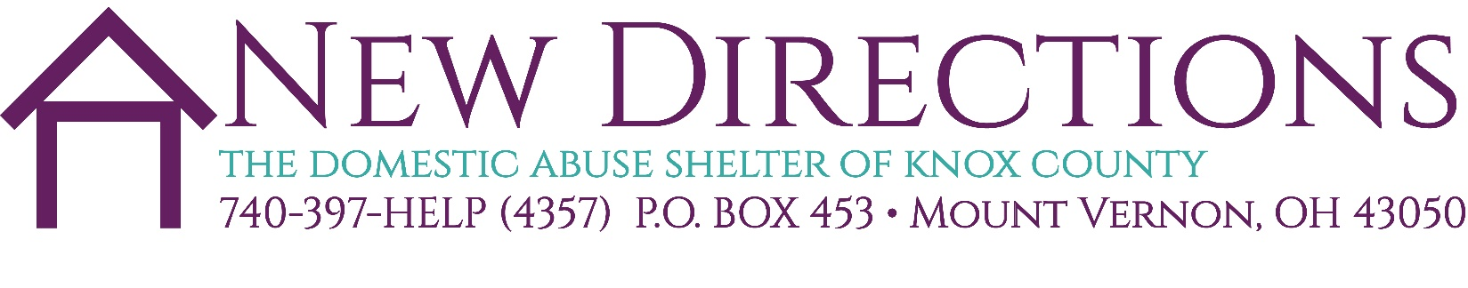

APPLICATION FOR BOARD MEMBER SERVICE

Visit our website to learn more about our organization’s Mission, Vision and
Commitment to diversity & inclusion.
https://www.newdirectionsknox.org/about/

We are seeking board members with a desire and passion to help us develop and maintain our goals. Our work is focused on prevention and education related to domestic/sexual violence; youth leadership programming; professional development; parent and child education; legal and court advocacy; and community events.

Our Board meets
How often: Every other month
Location: Currently at Woodward Opera House Board room. We will meet at 212 N. Main St., Mt. Vernon when we move to our new location.
Time: 3:00pm (subject to change)

Please provide the following information about yourself. Thank you for your interest in serving on our board. All applications will be reviewed and candidates will be contacted. Please return the complete application to Lori Jones-Perkins, Executive Director, lori@newdirectionsshelter.org no later than June 30, 2022.
- Name:
- Mailing Address:
- Email:
- Telephone:
- Employer:
- Past board and community service:
- What qualities do you feel you will bring to our board?
- Is there anything else you wish to share?
- What questions do you have for us?

