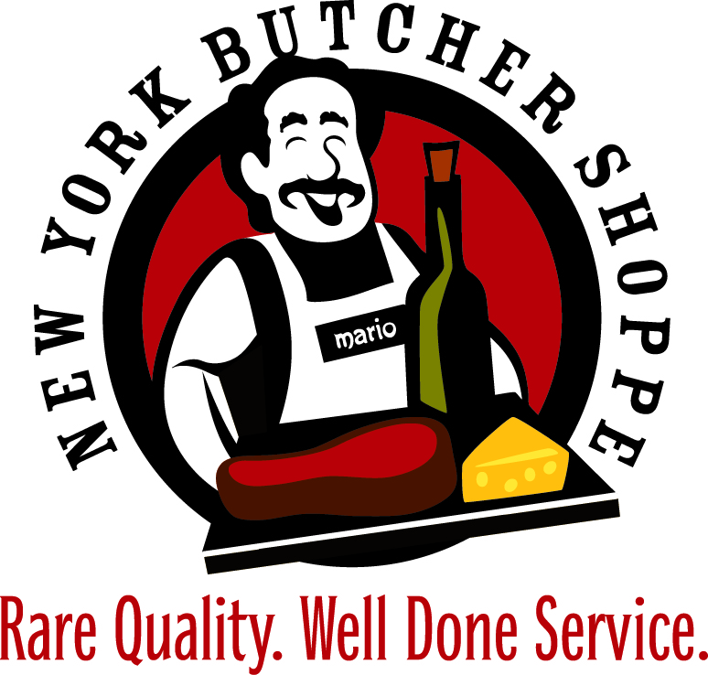
CHRISTMAS SIDE DISHES MENU
We are committed to making your celebration easier and more enjoyable by offering some high-quality side items, in addition to our delicious high-quality Roasts.
Each Side Item Servers 6 to 8 people and is Chef Prepared for your table:
Green bean Casserole - $27.99
Mashed Potatoes - $29.99
Mashed Sweet Potatoes - $29.99
Traditional Beef Gravy - $14.99
Prepared Horseradish 8oz- $7.99
Horseradish Cream Sauce 8z- $8.99
Au Jus- 32oz- $13.99
Broccoli Salad - $27.99
Harvest Vegetables - $27.99
Creamed Corn - $27.99
Mac and Cheese - $27.99
Broccoli Casserole - $27.99
Cranberry Sauce - $14.99
Sausage/Egg Casserole (Breakfast) - $29.99
Please place your orders early!

