SECTION 1: IDENTIFICATION

1.1. Product Identifier
Product Form: Mixture
Product Name: Summer Bug Wash

1.2. Intended Use of the Product Clean Windshields and glass

1.3. Name, Address, and Telephone of the Responsible Party

Company

Clean Shield
820 Concord St. N, #109
South St. Paul, Minnesota 55075
T 844-214-6112

1.4. Emergency Telephone Number

Emergency Number | : | 844-214-6112

SECTION 2: HAZARDS IDENTIFICATION

2.1. Classification of the Substance or Mixture

GHS-US classification
Flam. Liq. 1 | H226
Acute Tox. 2 (Oral) | H301
Acute Tox. 2 (Dermal) | H311
Acute Tox. 1 (Inhalation:vapor) | H331
STOT SE 1 | H370
Full text of hazard classes and H-statements : see section 16

2.2. Label Elements

GHS-US Labeling
Hazard Pictograms (GHS-US) | : | 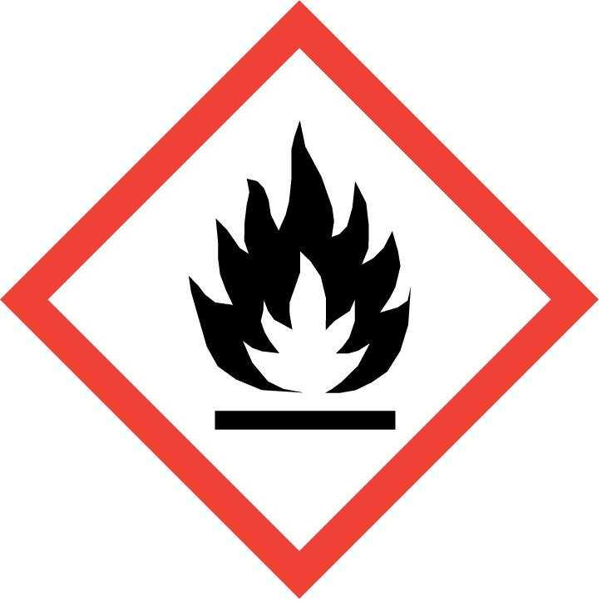  GHS02 | 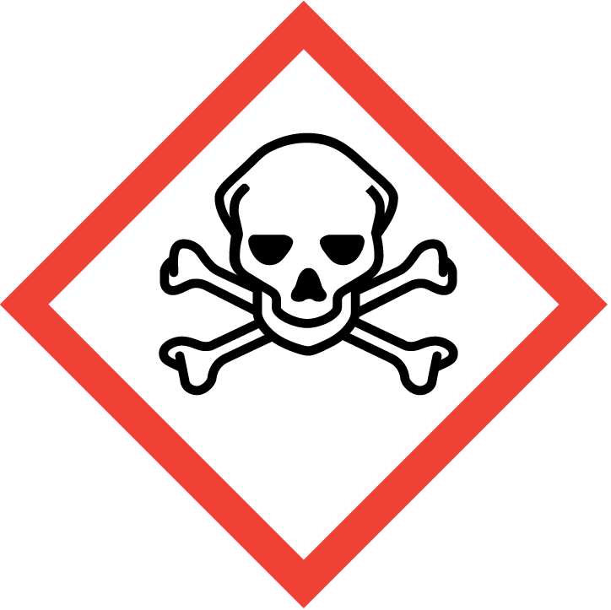  GHS06 | 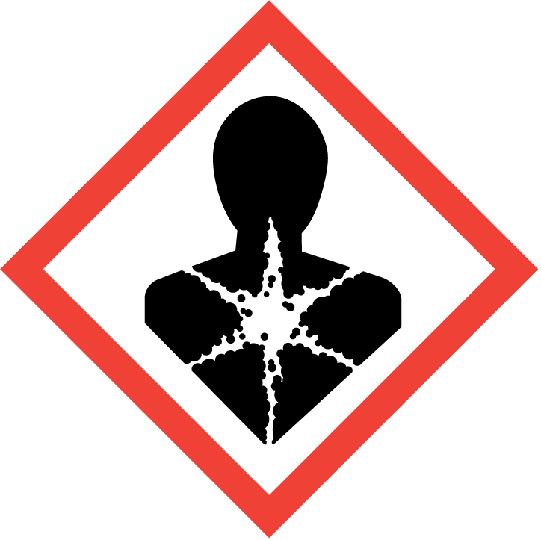  GHS08
Signal Word (GHS-US) | : | Danger
Hazard Statements (GHS-US) | : | H226 - Flammable liquid and vapor.  H301+H311+H331 - Toxic if swallowed, in contact with skin or if inhaled.  H370 - Causes damage to organs.
Precautionary Statements (GHS-US) | : | P210 - Keep away from extremely high or low temperatures, ignition sources, and incompatible materials. - No smoking.  P240 - Ground/bond container and receiving equipment.  P241 - Use explosion-proof electrical, ventilating, and lighting equipment.  P242 - Use only non-sparking tools.  P243 - Take precautionary measures against static discharge.  P260 - Do not breathe vapors, mist, or spray.  P264 - Wash hands, forearms, and other exposed areas thoroughly after handling.  P270 - Do not eat, drink or smoke when using this product.  P271 - Use only outdoors or in a well-ventilated area.  P280 - Wear protective gloves, protective clothing, and eye protection.  P301+P310 - If swallowed: Immediately call a poison center or doctor.  P303+P361+P353 - If on skin (or hair): Take off immediately all contaminated clothing. Rinse skin with water/shower.  P304+P340 - If inhaled: Remove person to fresh air and keep at rest in a position comfortable for breathing.  P307+P311 - If exposed: Call a poison center/doctor.  P311 - Call a poison center or doctor.  P312 - Call a poison center or doctor if you feel unwell.  P321 - Specific treatment (see section 4 on this SDS).  P330 - Rinse mouth.  P361 - Take off immediately all contaminated clothing.  P363 - Wash contaminated clothing before reuse.  P370+P378 - In case of fire: Use dry chemical powder, alcohol-resistant foam, carbon dioxide to extinguish.  P405 - Store locked up.  P501 - Dispose of contents/container in accordance with local, regional, national, and international regulations.  P403+P233+P235 - Store in a well-ventilated place. Keep container tightly closed. Keep cool.

2.3. Other Hazards
This material contains methanol, which, when ingested, may cause acidosis and ocular toxicity ranging from diminished visual capacity to complete blindness, and possible death. Methanol cannot be detected by its odor before reaching the dangerous exposure limit. Exposure may aggravate pre-existing eye, skin, or respiratory conditions.

2.4. Unknown Acute Toxicity (GHS-US)
No data available
SECTION 3: COMPOSITION/INFORMATION ON INGREDIENTS

3.1. Substance
Not applicable

3.2. Mixture
Name | Product Identifier | % | GHS-US classification
Water | (CAS No) 7732-18-5 | 85 | Not classified
Methyl alcohol | (CAS No) 67-56-1 | 15 | Flam. Liq. 2, H225  Acute Tox. 3 (Oral), H301  Acute Tox. 3 (Dermal), H311  Acute Tox. 3 (Inhalation:vapor), H331  STOT SE 1, H370
Full text of H-phrases: see section 16

SECTION 4: FIRST AID MEASURES

4.1. Description of First Aid Measures
First-aid Measures General: Never give anything by mouth to an unconscious person. If you feel unwell, seek medical advice (show the label where possible).
First-aid Measures After Inhalation: When symptoms occur: go into open air and ventilate suspected area. First, take proper precautions to ensure your own safety before attempting rescue (e.g. wear appropriate respiratory protective equipment, use the buddy system), then remove the exposed person to fresh air. Keep at rest in a position comfortable for breathing. Immediately call a POISON CENTER or doctor/physician.
First-aid Measures After Skin Contact: Remove contaminated clothing. Rinse immediately with plenty of water (for at least 15 minutes). Remove contaminated clothing. Drench affected area with water for at least 15 minutes. Get immediate medical advice/attention.
First-aid Measures After Eye Contact: Rinse cautiously with water for at least 15 minutes. Remove contact lenses, if present and easy to do. Continue rinsing. Get immediate medical advice/attention.
First-aid Measures After Ingestion: Do NOT induce vomiting. Rinse mouth. Immediately call a POISON CENTER or doctor.

4.2. Most important symptoms and effects, both acute and delayed
Symptoms/Injuries: Toxic if swallowed, in contact with skin or if inhaled. Causes damage to organs. Symptoms may be delayed.
Symptoms/Injuries After Inhalation: Inhalation of this material can cause serious health effects in small amounts, leading to unconsciousness and death. Inhalation may affect the nervous system causing headache, possibly dizziness, nausea, weakness, loss of coordination and unconsciousness.
Symptoms/Injuries After Skin Contact: This material is toxic in small amounts through skin contact, and can cause adverse health effects or death. This material may be absorbed through the skin and eyes. When absorbed through the skin may cause narcotic effects, headaches, nausea, fatigue, loss of consciousness, and death.
Symptoms/Injuries After Eye Contact: May cause eye irritation. Vapors may cause severe irritation and tearing.
Symptoms/Injuries After Ingestion: This material is toxic in small amounts orally, and can cause adverse health effects or death. This material contains methanol, which, when ingested, may cause acidosis and ocular toxicity ranging from diminished visual capacity to complete blindness, and possible death.
Chronic Symptoms: Repeated or prolonged skin contact may cause dermatitis and defatting. Symptoms of repeat exposure include headache, impaired vision.

4.3. Indication of Any Immediate Medical Attention and Special Treatment Needed
If exposed or concerned, get medical advice and attention. If medical advice is needed, have product container or label at hand.

SECTION 5: FIRE-FIGHTING MEASURES

5.1. Extinguishing Media
Suitable Extinguishing Media: Dry chemical powder, alcohol-resistant foam, carbon dioxide (CO₂). Water may be ineffective but water should be used to keep fire-exposed container cool.
Unsuitable Extinguishing Media: Do not use a heavy water stream. A heavy water stream may spread burning liquid.

5.2. Special Hazards Arising From the Substance or Mixture
Fire Hazard: Flammable liquid and vapor. Vapors are heavier than air and may travel considerable distance to an ignition source and flash back to source of vapors. Methanol burns with a clear flame that is very difficult to see in daylight.
Explosion Hazard: May form flammable or explosive vapor-air mixture. Container may explode in heat of fire.
Reactivity: Reacts violently with strong oxidizers. Increased risk of fire or explosion. This material may attack some forms of plastics, rubbers and coatings. May be corrosive to metals. Contact with metals may evolve flammable hydrogen gas.

5.3. Advice for Firefighters
Precautionary Measures Fire: Exercise caution when fighting any chemical fire.
Firefighting Instructions: Use water spray or fog for cooling exposed containers. In case of major fire and large quantities: Evacuate area. Fight fire remotely due to the risk of explosion.
Protection During Firefighting: Do not enter fire area without proper protective equipment, including respiratory protection.

SECTION 6: ACCIDENTAL RELEASE MEASURES

6.1. Personal Precautions, Protective Equipment and Emergency Procedures
General Measures: Do not get in eyes, on skin, or on clothing. Do not breathe vapor, mist or spray. Keep away from heat, hot surfaces, sparks, open flames, and other ignition sources. No smoking. Use special care to avoid static electric charges.

6.1.1. For Non-emergency Personnel
Protective Equipment: Use appropriate personal protection equipment (PPE).
Emergency Procedures: Evacuate unnecessary personnel. Stop leak if safe to do so.
6.1.2. For Emergency Responders
Protective Equipment: Equip cleanup crew with proper protection.
Emergency Procedures: Upon arrival at the scene, a first responder is expected to recognize the presence of dangerous goods, protect oneself and the public, secure the area, and call for the assistance of trained personnel as soon as conditions permit.

6.2. Environmental Precautions
Prevent entry to sewers and public waters.

6.3. Methods and Material for Containment and Cleaning Up
For Containment: Contain any spills with dikes or absorbents to prevent migration and entry into sewers or streams. As an immediate precautionary measure, isolate spill or leak area in all directions. Ventilate area.
Methods for Cleaning Up: Clean up spills immediately and dispose of waste safely. Transfer spilled material to a suitable container for disposal. Contact competent authorities after a spill. Absorb and/or contain spill with inert material. Do not take up in combustible material such as: saw dust or cellulosic material. Use only non-sparking tools.

6.4. Reference to Other Sections
See Section 8 for exposure controls and personal protection and Section 13 for disposal considerations.

SECTION 7: HANDLING AND STORAGE

7.1. Precautions for Safe Handling
Additional Hazards When Processed: Handle empty containers with care because residual vapors are flammable. Do not pressurize, cut, or weld containers.
Precautions for Safe Handling: Wash hands and other exposed areas with mild soap and water before eating, drinking or smoking and when leaving work. Take precautionary measures against static discharge. Use only non-sparking tools. Handle empty containers with care because they may still present a hazard. Use only outdoors or in a well-ventilated area. Do not get in eyes, on skin, or on clothing. Do not breathe vapors, mist, spray.
Hygiene Measures: Handle in accordance with good industrial hygiene and safety procedures.

7.2. Conditions for Safe Storage, Including Any Incompatibilities
Technical Measures: Comply with applicable regulations. Take action to prevent static discharges. Ground and bond container and receiving equipment. Use explosion-proof electrical, ventilating, and lighting equipment.
Storage Conditions: Store in a dry, cool place. Keep/Store away from direct sunlight, extremely high or low temperatures and incompatible materials. Store in a well-ventilated place. Keep container tightly closed. Keep in fireproof place. Store locked up.
Incompatible Products: Strong oxidizers. Strong mineral acids. Organic acids. Strong bases.
7.3. Specific End Use(s) No additional information available

SECTION 8: EXPOSURE CONTROLS/PERSONAL PROTECTION

8.1. Control Parameters
For substances listed in section 3 that are not listed here, there are no established exposure limits from the manufacturer, supplier, importer, or the appropriate advisory agency including: ACGIH (TLV), AIHA (WEEL), NIOSH (REL), or OSHA (PEL).
Methyl alcohol (67-56-1)
USA ACGIH | ACGIH TWA (ppm) | 200 ppm
USA ACGIH | ACGIH STEL (ppm) | 250 ppm
USA ACGIH | ACGIH chemical category | Skin - potential significant contribution to overall exposure by the cutaneous route
USA ACGIH | Biological Exposure Indices (BEI) | 15 mg/l (Medium: urine - Time: end of shift - Parameter: Methanol (background, nonspecific)
USA NIOSH | NIOSH REL (TWA) (mg/m³) | 260 mg/m³
USA NIOSH | NIOSH REL (TWA) (ppm) | 200 ppm
USA NIOSH | NIOSH REL (STEL) (mg/m³) | 325 mg/m³
USA NIOSH | NIOSH REL (STEL) (ppm) | 250 ppm
USA IDLH | US IDLH (ppm) | 6000 ppm
USA OSHA | OSHA PEL (TWA) (mg/m³) | 260 mg/m³
USA OSHA | OSHA PEL (TWA) (ppm) | 200 ppm
8.2. Exposure Controls
Appropriate Engineering Controls | : | Local exhaust and general ventilation must be adequate to meet exposure standards. Site-specific risk assessments should be conducted to determine the appropriate exposure control measures. If applicable, use process enclosures, local exhaust ventilation, or other engineering controls to maintain airborne levels below recommended exposure limits. Gas detectors should be used when flammable gases or vapors may be released. Proper grounding procedures to avoid static electricity should be followed. Use explosion-proof equipment. Gas detectors should be used when toxic gases may be released. Emergency eye wash fountain capability should be available in the immediate vicinity of any potential exposure. Ensure all national/local regulations are observed.
Personal Protective Equipment | : | Gloves. Protective clothing. Protective goggles. Insufficient ventilation: wear respiratory protection.  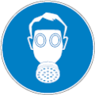
Materials for Protective Clothing | : | Chemically resistant materials and fabrics. Wear fire/flame resistant/retardant clothing.
Hand Protection | : | Wear protective gloves.
Eye Protection | : | Chemical safety goggles.
Skin and Body Protection | : | Wear suitable protective clothing. Splash hazard: wear face shield.
Respiratory Protection | : | If exposure limits are exceeded or irritation is experienced, approved respiratory protection should be worn. In case of inadequate ventilation, oxygen deficient atmosphere, or where exposure levels are not known wear approved respiratory protection.
Other Information | : | When using, do not eat, drink or smoke.

SECTION 9: PHYSICAL AND CHEMICAL PROPERTIES

9.1. Information on Basic Physical and Chemical Properties
Physical State | : | Liquid
Appearance | : | Blue
Odor | : | No data available
Odor Threshold | : | No data available
pH | : | No data available
Evaporation Rate | : | No data available
Melting Point | : | No data available
Freezing Point | : | No data available
Boiling Point | : | No data available
Flash Point | : | 143 °F
Auto-ignition Temperature | : | No data available
Decomposition Temperature | : | No data available
Flammability (solid, gas) | : | No data available
Vapor Pressure | : | No data available
Relative Vapor Density at 20 °C | : | No data available
Relative Density | : | No data available
Solubility | : | No data available
Partition Coefficient: N-Octanol/Water | : | No data available
Viscosity | : | No data available
9.2. Other Information
VOC content | : | 15 %

SECTION 10: STABILITY AND REACTIVITY

10.1. Reactivity: Reacts with strong oxidizers. Low risk of fire or explosion. This material may attack some forms of plastics, rubbers and coatings. May be corrosive to metals. Contact with metals may evolve flammable hydrogen gas.

10.2. Chemical Stability: Flammable liquid and vapor. May form flammable or explosive vapor-air mixture.

10.3. Possibility of Hazardous Reactions: Hazardous polymerization will not occur.

10.4. Conditions to Avoid: Direct sunlight, extremely high or low temperatures, heat, hot surfaces, sparks, open flames, incompatible materials, and other ignition sources.

10.5. Incompatible Materials: Strong oxidizers. Strong mineral acids. Organic acids. Strong bases.

10.6. Hazardous Decomposition Products: Thermal decomposition generates: Carbon oxides (CO, CO₂). Formaldehyde. Formaldeyhde is a potential carcinogen and can act as a potential skin and respiratory sensitizer. Formaldehyde can also cause respiratory and eye irritation.

SECTION 11: TOXICOLOGICAL INFORMATION

11.1. Information On Toxicological Effects
Acute Toxicity: Oral: Toxic if swallowed. Dermal: Toxic in contact with skin. Inhalation:vapour: Toxic if inhaled.

Summer Bug Wash
ATE (Oral) | 266.67 mg/kg body weight
ATE (Dermal) | 800.00 mg/kg body weight
ATE (Vapors) | 8.00 mg/l/4h

Methyl alcohol (67-56-1)
LD50 Oral Rat | 6200 mg/kg
LC50 Inhalation Rat | 3 mg/l/4h
LC50 Inhalation Rat | 22500 ppm (Exposure time: 8 h)
ATE (Dermal) | 300.00 mg/kg body weight
Skin Corrosion/Irritation: Not classified
Serious Eye Damage/Irritation: Not classified
Respiratory or Skin Sensitization: Not classified
Germ Cell Mutagenicity: Not classified
Carcinogenicity: Not classified
Reproductive Toxicity: Not classified
Specific Target Organ Toxicity (Single Exposure): Causes damage to organs.
Specific Target Organ Toxicity (Repeated Exposure): Not classified
Aspiration Hazard: Not classified
Symptoms/Injuries After Inhalation: Inhalation of this material can cause serious health effects in small amounts, leading to unconsciousness and death. Inhalation may affect the nervous system causing headache, possibly dizziness, nausea, weakness, loss of coordination and unconsciousness.
Symptoms/Injuries After Skin Contact: This material is toxic in small amounts through skin contact, and can cause adverse health effects or death. This material may be absorbed through the skin and eyes. When absorbed through the skin may cause narcotic effects, headaches, nausea, fatigue, loss of consciousness, and death.
Symptoms/Injuries After Eye Contact: May cause eye irritation. Vapors may cause severe irritation and tearing.
Symptoms/Injuries After Ingestion: This material is toxic in small amounts orally, and can cause adverse health effects or death. . This material contains methanol, which, when ingested, may cause acidosis and ocular toxicity ranging from diminished visual capacity to complete blindness, and possible death.
Chronic Symptoms: Repeated or prolonged skin contact may cause dermatitis and defatting. Symptoms of repeat exposure include headache, impaired vision.

SECTION 12: ECOLOGICAL INFORMATION

12.1. Toxicity
Ecology - General | : | Not classified.

Methyl alcohol (67-56-1)
LC50 Fish 1 | 28200 mg/l (Exposure time: 96 h - Species: Pimephales promelas [flow-through])
EC50 Daphnia 1 | 1340 mg/l
LC 50 Fish 2 | > 100 mg/l (Exposure time: 96 h - Species: Pimephales promelas [static])

12.2. Persistence and Degradability Not established

12.3. Bioaccumulative Potential
Methyl alcohol (67-56-1)
BCF fish 1 | < 10
Log Pow | -0.77

12.4. Mobility in Soil No additional information available
12.5. Other Adverse Effects
Other Information | : | Avoid release to the environment.

SECTION 13: DISPOSAL CONSIDERATIONS

13.1. Waste treatment methods
Waste Disposal Recommendations: Dispose of contents/container in accordance with local, regional, national, and international regulations.
Additional Information: Handle empty containers with care because residual vapors are flammable.
Ecology – Waste Materials: Avoid release to the environment.

SECTION 14: TRANSPORT INFORMATION
14.1. In Accordance with DOT
Proper Shipping Name | : | FLAMMABLE LIQUIDS, TOXIC, N.O.S. (Methanol solution)
Hazard Class | : | 3 | 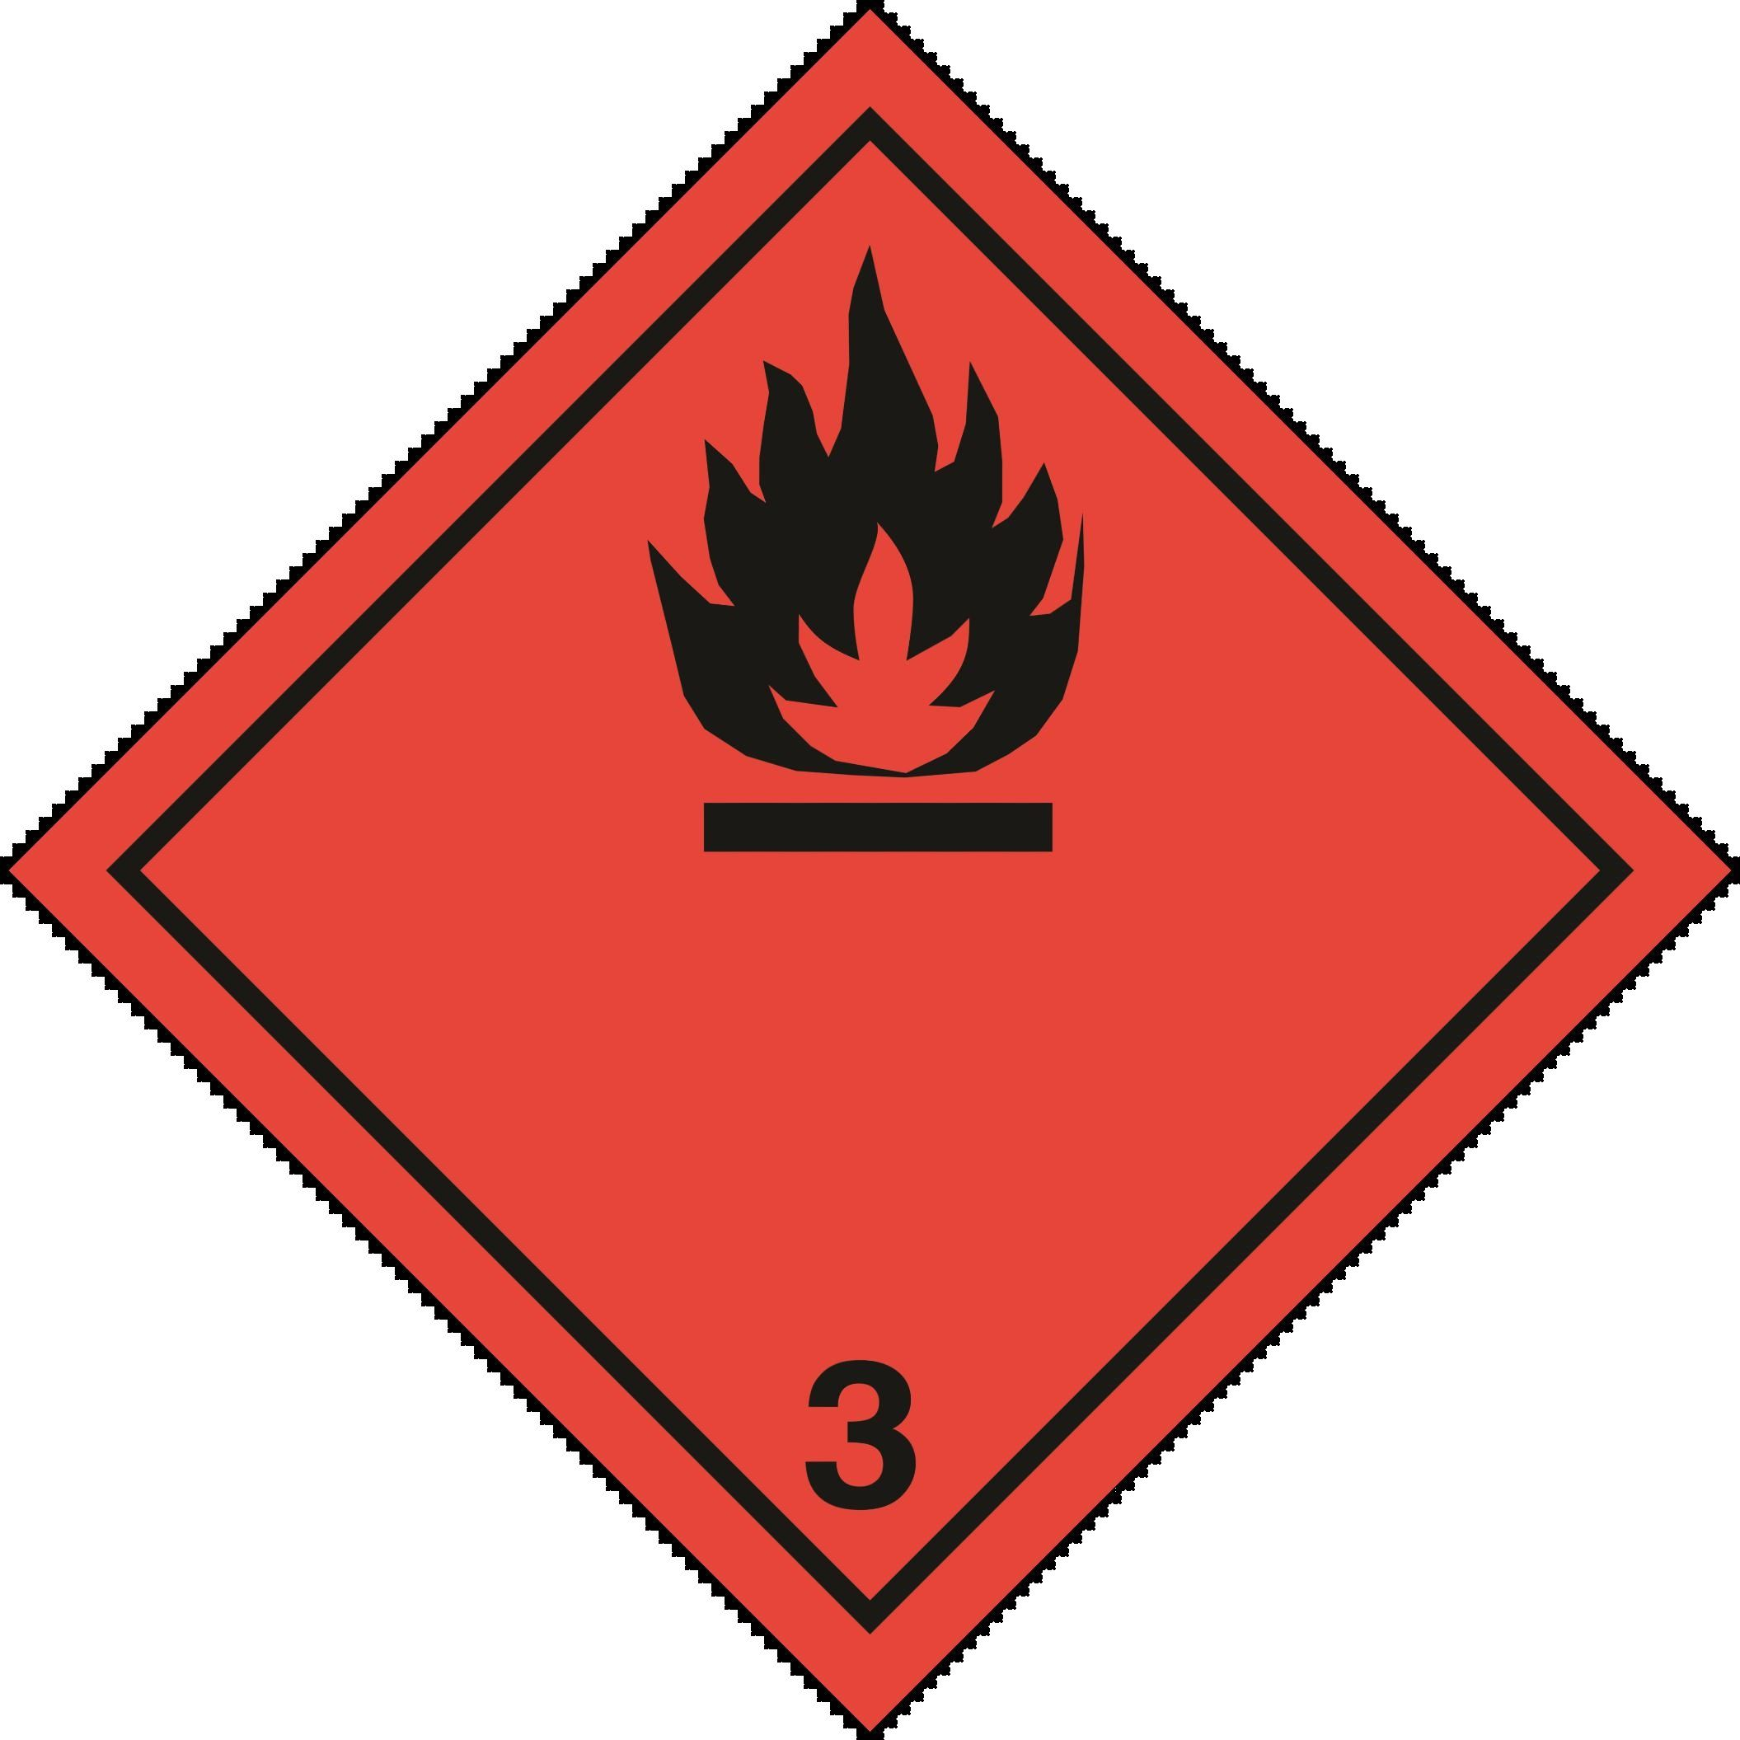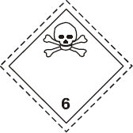
Identification Number | : | UN1230
Label Codes | : | 3, 6.1
Packing Group | : | III
ERG Number | : | 131
14.2. In Accordance with IMDG
Proper Shipping Name | : | FLAMMABLE LIQUID, TOXIC, N.O.S. (Methanol solution)
Hazard Class | : | 3 | 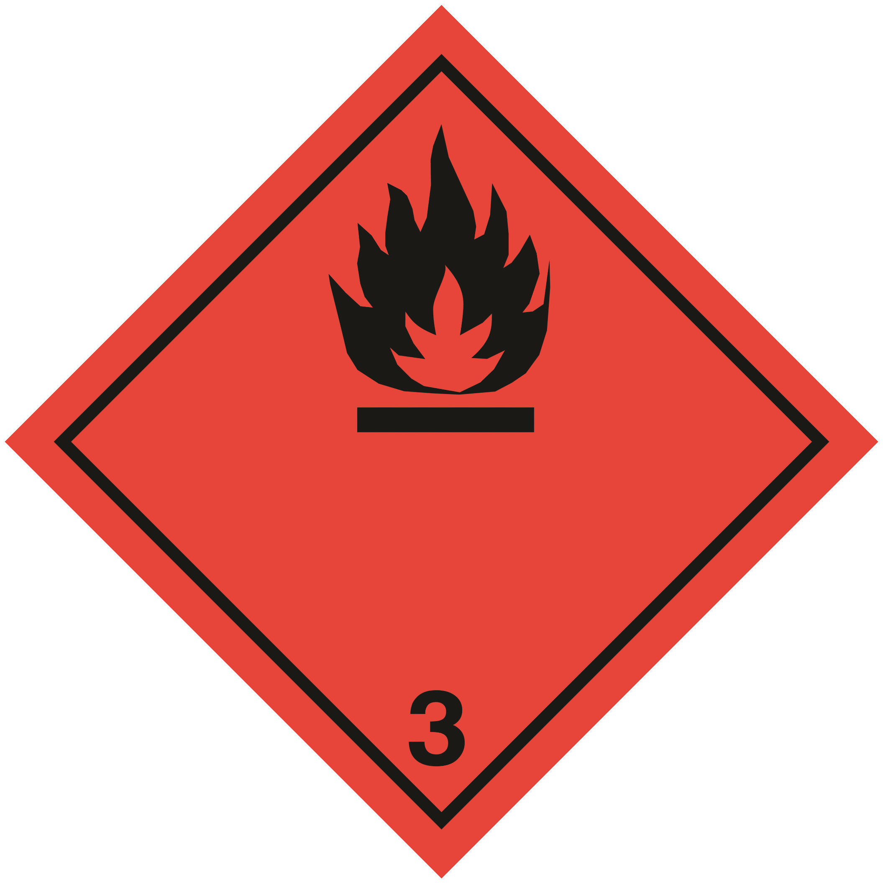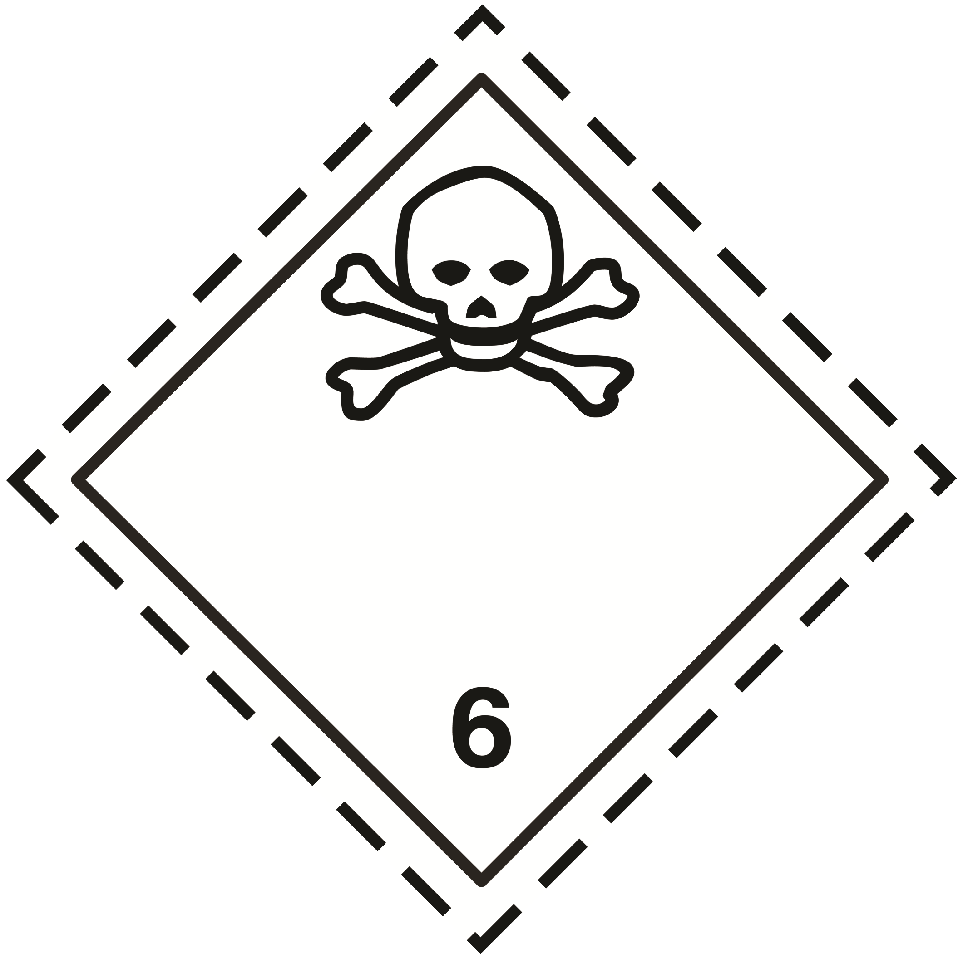
Subsidiary Risk(s) | : | 6.1
Identification Number | : | UN1230
Packing Group | : | III
Label Codes | : | 3, 6.1
EmS-No. (Fire) | : | F-E
EmS-No. (Spillage) | : | S-D
14.3. In Accordance with IATA
Proper Shipping Name | : | FLAMMABLE LIQUID, TOXIC, N.O.S. (Methanol solution)
Packing Group | : | III
Identification Number | : | UN1230
Hazard Class | : | 3
Label Codes | : | 3, 6.1
Subsidiary Risk(s) | : | 6.1
ERG Code (IATA) | : | 3P

SECTION 15: REGULATORY INFORMATION

15.1 US Federal Regulations
Premium Wash -25
SARA Section 311/312 Hazard Classes | Fire hazard  Immediate (acute) health hazard

Methyl alcohol (67-56-1)
Listed on the United States TSCA (Toxic Substances Control Act) inventory
Subject to reporting requirements of United States SARA Section 313
SARA Section 313 - Emission Reporting | 1.0 %

Water (7732-18-5)
Listed on the United States TSCA (Toxic Substances Control Act) inventory

15.2 US State Regulations
Methyl alcohol (67-56-1)
U.S. - California - Proposition 65 - Developmental Toxicity | WARNING: This product contains chemicals known to the State of California to cause birth defects.

Methyl alcohol (67-56-1)
U.S. - Massachusetts - Right To Know List
U.S. - New Jersey - Right to Know Hazardous Substance List
U.S. - Pennsylvania - RTK (Right to Know) - Environmental Hazard List
U.S. - Pennsylvania - RTK (Right to Know) List

SECTION 16: OTHER INFORMATION, INCLUDING DATE OF PREPARATION OR LAST REVISION
Revision Date | : | 03/08/2016
Other Information | : | This document has been prepared in accordance with the SDS requirements of the OSHA Hazard Communication Standard 29 CFR 1910.1200.

GHS Full Text Phrases:
------ | Acute Tox. 3 (Dermal) | Acute toxicity (dermal) Category 3
------ | Acute Tox. 3 (Inhalation:vapor) | Acute toxicity (inhalation:vapor) Category 3
------ | Acute Tox. 3 (Oral) | Acute toxicity (oral) Category 3
------ | Flam. Liq. 2 | Flammable liquids Category 2
------ | Flam. Liq. 3 | Flammable liquids Category 3
------ | STOT SE 1 | Specific target organ toxicity (single exposure) Category 1
------ | H225 | Highly flammable liquid and vapor
------ | H226 | Flammable liquid and vapor
------ | H301 | Toxic if swallowed
------ | H311 | Toxic in contact with skin
------ | H331 | Toxic if inhaled
------ | H370 | Causes damage to organs

This information is based on our current knowledge and is intended to describe the product for the purposes of health, safety and environmental requirements only. It should not therefore be construed as guaranteeing any specific property of the product.

SDS US (GHS HazCom)

